**Exercise 1**

**Factorial Application Bug Report** (By Munish Verma)

**Defect ID:** Factorial_DF001

**Date Time Stamp:** 22-June-2021, 12:46 PM

**Reported By:** Munish Verma

**Assigned To:** Development Team

**Status:** New

**Defect Summary:** Clicking on “Terms and Conditions” link on the factorial application home page opens wrong page (opens “Privacy” page)

**Test Case Summary:** Access/open “Terms and Conditions” document page.

**Test case ID:** Factorial_TC001

**Steps to Reproduce:**

Step 1: Open the application using link <https://qainterview.pythonanywhere.com/>

Step 2: Click on “Terms and Conditions” to access the Terms and Conditions document page.

Step 3: Verify the contents of the page to ensure that “Terms and Conditions” document page successfully opens.

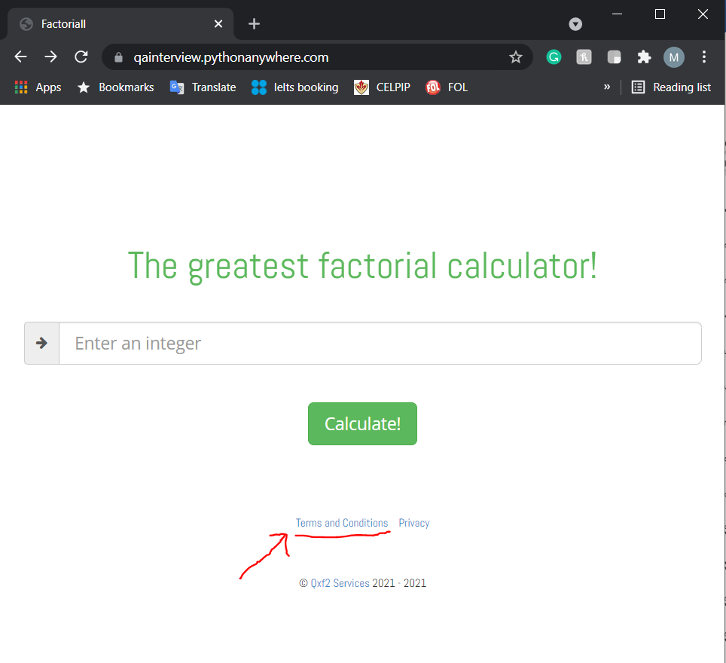

**Expected Result:** Upon clicking on the “Terms and Conditions” option, the Terms and Conditions document should open.

**Actual Result:** Upon clicking on the “Terms and Conditions” option, the “Privacy” document page is accessed.

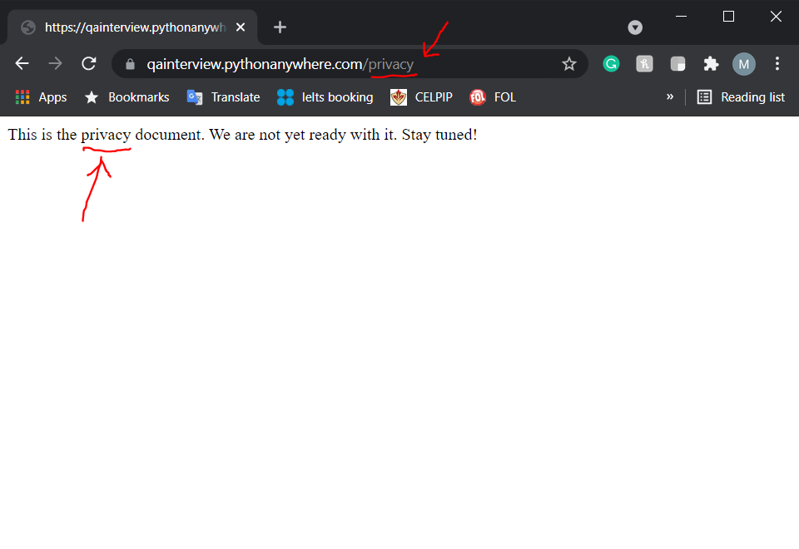

**Detailed Bug Description:**

Upon clicking on the “Terms and Conditions” link on the application home page, it is expected that the correct page (i.e. Terms and Conditions document) is accessed and opened. Whereas, upon clicking on the “Terms and Conditions” link on the application homepage, the “Privacy” document page is accessed and opened.

**Defect ID:** Factorial_DF002

**Date Time Stamp:** 22-June-2021, 12:50 PM

**Reported By:** Munish Verma

**Assigned To:** Development Team

**Status:** New

**Defect Summary:** Clicking on “Privacy” link on the factorial application home page opens wrong page (opens “Terms and Conditions” page)

**Test Case Summary:** Access/open “Privacy” document page.

**Test case ID:** Factorial_TC002

**Steps to Reproduce:**

Step 1: Open the application using link <https://qainterview.pythonanywhere.com/>

Step 2: Click on “Privacy” link to access the Privacy document page.

Step 3: Verify the contents of the page to ensure that “Privacy” document page successfully opens.

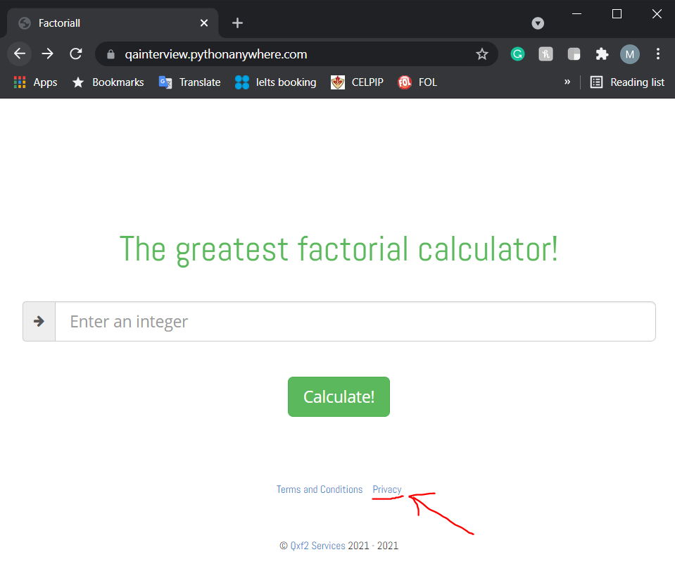

**Expected Result:** Upon clicking on the “Privacy” option, the Privacy document should open.

**Actual Result:** Upon clicking on the “Privacy” option, the “Terms and Conditions” document page is accessed.

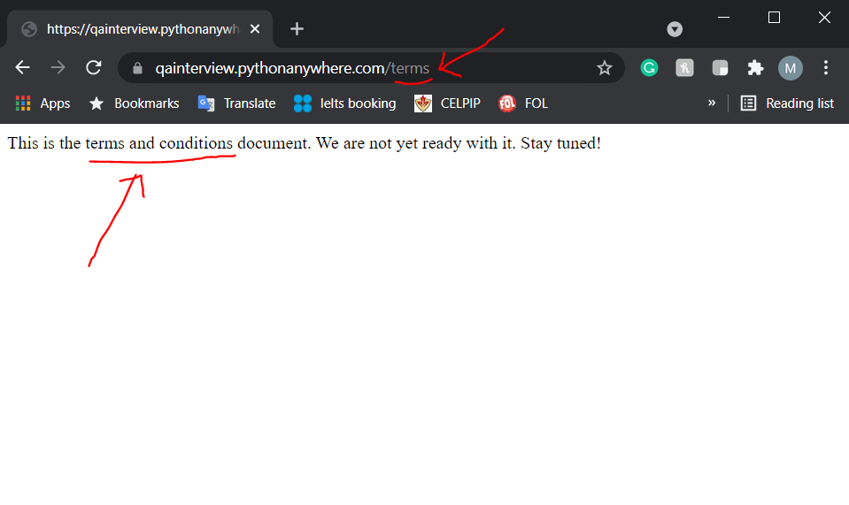

**Detailed Description:**

Upon clicking on the “Privacy” link on the application home page, it is expected that the correct page (i.e. Privacy document) is accessed and opened. Whereas, upon clicking on the “Privacy” link on the application homepage, the “Terms and Conditions” document page is accessed and opened.